
The Veterans Way Bulletin
Royal Canadian Legion
Branch 121 (Galt)
March - April 2026

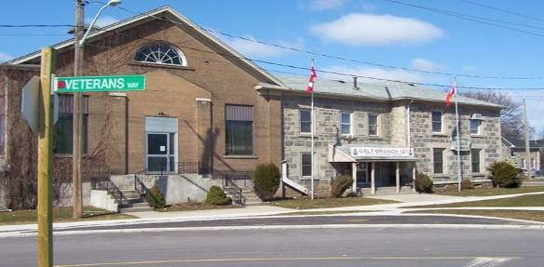
RCL Branch 121
hrs of Business Srarting Sept. 8/25
Mondays OPEN 6 - 10
Tuesday OPEN 6 - 10
Wednesday OPEN 6 - 10
Thursday OPEN 6 - 10
Friday OPEN 6 - 11
Saturday OPEN 12:00 - 6:00
Sunday CLOSED
Statutory Holidays Closed

4 Veterans Way
Cambridge, Ont.
N1R 3K7

Phone: 519-621-5850
Fax: 519-621-6807
Email:121galtlegion@gmail.com
Legion Web: http://www.galtlegion121.ca
Hall Rentals requests email to:
legionentertainment@hotmail.com

General Meeting Held 3rd Thursday of the month 7:30 p.m.
No general meeting in July, August and December

Executive Meeting Held every 2nd Tuesday of the Month 7:00 p.m.
Bulletin Editor: Annie Thirtle email: lala.thirtle@gmail.com

Executive/Committee for Branch 121 & LAdies Auxilary Listings 2025 - 2027

2 Year Term: June 1, 2025– May 31, 2027

Standing Executive
Position | First Name | Last Name | Phone #
President | Micheline (Mook) | King
Past President | Vacant
1st Vice President | Sandra | Curtis
2nd Vice President | Peter | Beswick
Secretary | Annie | Wilson
Treasurer / Financial Security | Paula | Baxter-Taylor
Sgt-at-Arms | Mark | McKane
Leadership & Development | Rob | Kleri
Membership | Annie  Rob | Wilson  Kleri
Poppy Chairman | Donna | Paquin
PRO | Don | Taylor
Seniors | Peter | Beswick
Sports / Track and Field | Jim | Hickey
Veterans Service Officer | Peter | Beswick
Bursary/Youth Education | Ray | Boudreau

Branch Committees
Entertainment | Mook | King
Honours & Awards | Sandra / Lauralee | Curtis /Fox
House and Property | Sean | Curtis
Sick and Visiting | John Hynes / Margaret McNamara
Financial Review | Bonnie | Kitchen
Health Safety | Mark  Rob | McKane  Klein
Bar Chairman | Sandra | Curtis
Ways and Means | Annie  Mook | Wilson  King
Liaison Officer Cadets | Peter | Beswick

LADIES AUXILIARY EXECUTIVE
President / Seniors Dance & Dinner | Kerry | Evens
Past President / Catering | Betty | Laidlaw
1st Vice President | Diane | Hnatejko
2nd Vice President | Sherry | Coleman
Treasurer | Betty | Laidlaw
Secretary | Amy | Crowe
Sgt-at-Arms | Vacant
Sports officer | Amy | Crowe
Membership | Vanda | Noseworthy
Phone Chairperson | Cathy | McMurrin
Kitchen & Head Chef Coordinator | Sherry | Coleman
Volunteer Coordinator | Sherry | Coleman
Honours & Awards | Christine | Fulton
Email Ladies Auxiliary: LaAux121@gmail.com
Branch Chaplin | Rev. Frank | Squires



President’s Report

As we enter our Centennial Year, there is a real sense of excitement and momentum around the branch. This is a very special milestone for all of us. For 100 years, members before us built something meaningful, and now it is our turn to continue that legacy and look toward the future together.

It has been wonderful to see so many new members joining. When you see a new face, please take a moment to welcome them, introduce yourself, and show them that this is a warm, friendly place where everyone belongs. Small gestures go a long way in making people feel part of our Legion family.

We are currently preparing plans to celebrate our 100th anniversary this summer, and it will truly be something special. If you are interested in helping with the planning or volunteering your time, please send an email to the branch. The more members involved, the better our celebration will be.

As we move forward together, it is always encouraging to see members coming out and supporting our events. Bring a family member or a friend and let them experience the great community we have built here. With everyone’s support, the future of our branch is bright.

Here’s to celebrating our past, strengthening our present, and building an even brighter future together.

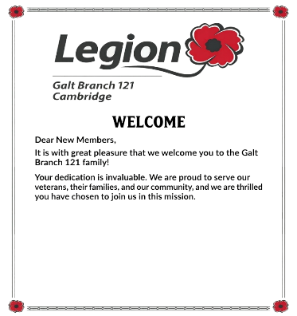
Micheline
President 🎖️

1st vice President
As I sit here writing this, I look outside and see the March storm that Mother Nature has decided to send our way. It reminds me how quickly things can change — and how lucky we are to have a place like our branch to gather, connect, and share in community.
Much like winter reminding us it hasn’t gone anywhere, our branch—once quiet—has come alive again, filling up with activity, laughter, and community.
I would like to extend a warm welcome to all of our new members, and also to those who have recently been finding activities to attend here at the branch. Without you, none of this works. Thank you for sticking with us and continuing to support this branch.
The building we all gather in has been part of this community for well over 100 years.
It has stood through many seasons, storms, and celebrations.
Because of its members like you — past, present, and future — who truly form the heart of it and keep its spirit alive

Sandra Curtis
1st Vice President

Poppy Report
Hello All,

The poppy donations were at total of $47,401.00 for last year. We are preparing for a bigger and better campaign this year. We are in the process of changing up the routes and ordering supplies needed.
Hopefully all is well with all fellow comrades.

Donna Paquin
Poppy Chair

Leadership and Development
First aid kits are finished and up to code.

Still looking for volunteers to help with mentorship program. Sign up is downstairs on white board.

First aid training is still being looked into as well. We might have found a more cost effective trainer.

Thank you,
Rob Kleri







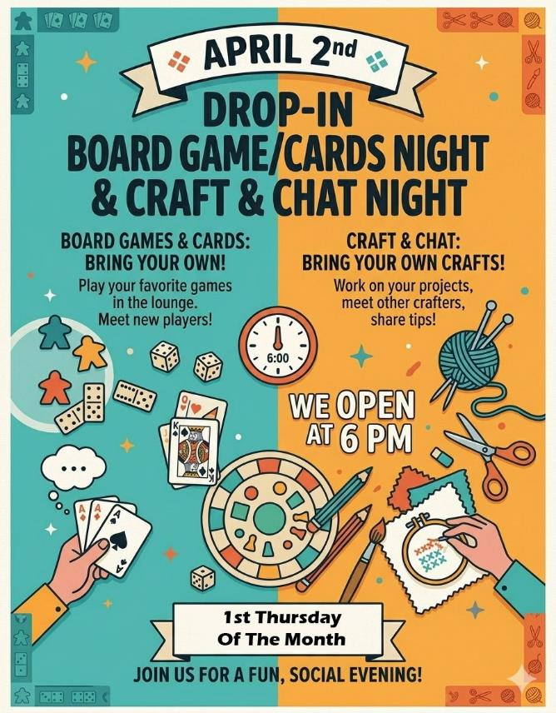

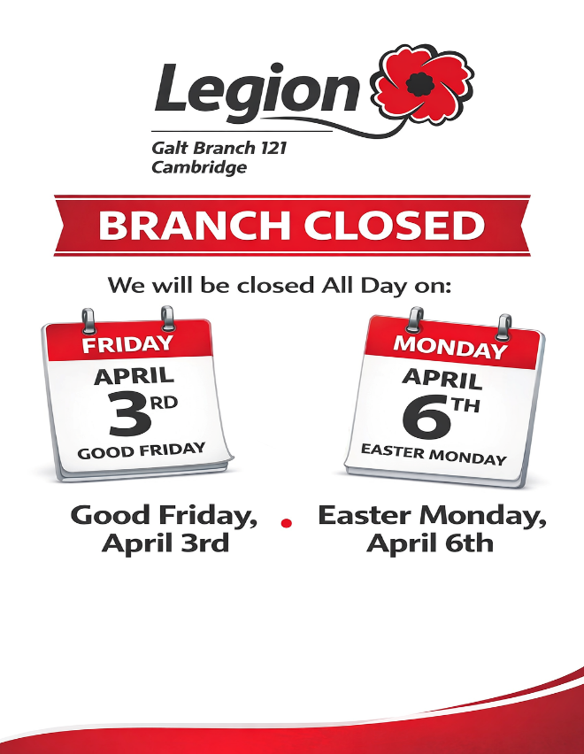

















BATTLE OF THE ATLANTIC MEMORIAL SERVICE

Sunday May 3th, 2026
1:00 pm
Churchill Park, Cambridge



Celebration to follow at the S.W.N.V.A.
30 Cambridge Street, Cambridge
Light Lunch & Salute

March - april 2026
 | SUN. | MON. | TUES. | WED. | THURS. | FRI. | SAT.
 | Branch  Closed | Branch  open 6-10 | Branch  Open 6- 10 | Branch  open 6-10 | BRANCH  open 6-10 | Branch  open 6-11 | Branch  open 12-6
 | ma. 15 |   mar. 1  7 pm | mar. 17  Blue Grass Jam night | mar. 18  League Snooker 6:30 | mar. 19  General  Meeting  7:30 | mar. 20   | mar.21  
 | mar. 22  Seniors D&D  DJ John J.  $20 pp  Dancing  2-4:30 | mar. 23  7 pm | mar. 24  Blue Grass Jam night | mar. 25  League Snooker 6:30 | mar. 26     | mar. 27  Karaoke  Kris G. | mar. 28
 | Mar. 29 | mar. 30  7 pm | mar. 31 Blue Grass Jam night | Apr. 1 League Snooker 6:30 | apr.2   | apr. 3  Good Friday  Closed | apr.4
 | apr. 5  Easter Sunday | apr. 6  Easter Monday  closed | apr. 7  Blue Grass Jam night | Apr. 8 League Snooker 6:30 | Apr. 9   | Apr. 10 Karaoke  Kris G. | Apr. 11
 | Apr. 12  LA Breakfast  8:30 - 11:00  Adults $12 pp  6-10 $5  5 & under free | Apr. 13  7 pm | Apr. 14 Blue Grass Jam night  EXEC. MTG.  7 pm | Apr. 15 League Snooker 6:30 | Apr. 16  General MTG 7:30 | Apr. 17   | Apr. 18
 | Apr. 19 | Apr. 20  7 pm | Apr. 21 Blue Grass Jam night | Apr. 22 League Snooker 6:30 | Apr. 23     | Apr. 24 Karaoke  Kris G. | Apr. 25  
 | Apr. 26 | Apr. 27  7 pm | Apr. 28 Blue Grass Jam night | Apr. 29 League Snooker 6:30 | Apr. 30 | May 1 Karaoke  Kris G. | may 2

