The Veterans Way Bulletin
MAY- JUNE 2026
 | 4 Veterans Way Cambridge, Ont.  N1R 3K7 Phone: 519-621-5850
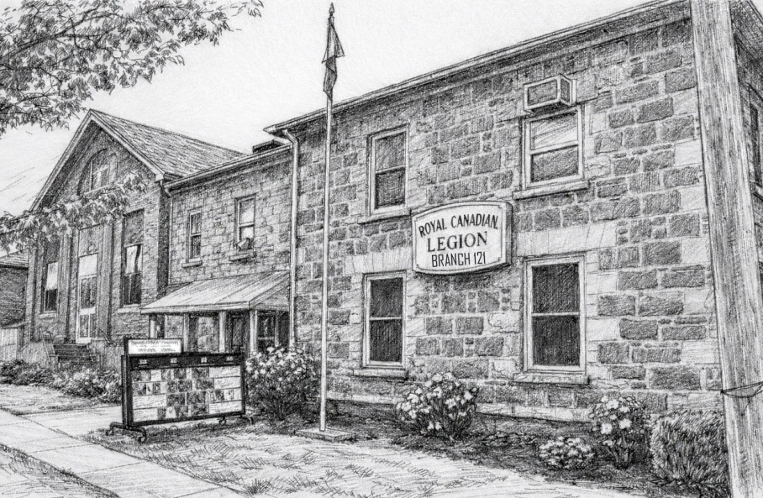

SEPTEMBER THROUGH JUNE LOUNGE HOURS

MONDAY | 6 PM TO 10 PM
TUESDAY | 6 PM TO 10 PM
WEDNESDAY | 6 PM TO 10 PM
THURSDAY | CLOSED
FRIDAY | 6 PM TO 11 PM
SATURDAY | 12 PM TO 6 PM -LATER FOR SOME EVENTS
SUNDAY | CLOSED

Email:121galtlegion@gmail.com Legion Web Page: http://www.galtlegion121.ca
Hall Rentals legionentertainment@hotmail.com Bulletin Submissions121galtlegion@gmail.com

General Meeting 3rd Thursday of the month 7:30 p.m. No general meeting in July, Aug & Dec

Executive Meeting Held every 2nd Tuesday of the Month 7:00 p.m.

Executive/Committee for Branch 121 & LAdies Auxilary Listings 2025 - 2027

2 Year Term: June 1, 2025– May 31, 2027

Standing Executive
Position | First Name | Last Name | Phone #
President | Micheline (Mook) | King | 226-218-3818
Past President | Vacant
1st Vice President | Sandra | Curtis | 226-218-5483
2nd Vice President | Peter | Beswick | 519-621-1749
Secretary | Annie | Wilson | 905-518-9741
Treasurer | Paula | Baxter - Taylor | 519-654-6468
Sgt-at-Arms | Mark | McKane | 226-755-0385
Leadership & Development | Rob | Kleri | 226-898-1779
Membership | Micheline (Mook) | King | 226-218-3818
Poppy Chairman
PRO | Don | Taylor | 416-709-7935
Seniors | Peter | Beswick | 519-621-1749
Sports / Track and Field | Jim | Hickey | 778-839-3930
Veterans Service Officer | Peter | Beswick | 519-621-1749
Bursary/Youth Education | Ray | Boudreau | 519-740-8422

Branch Committees
Entertainment | Mook | King | 226-218-3818
Honours & Awards | Lauralee | Fox | 519-240-8805
House and Property | Sean | Curtis | 226-218-3781
Sick and Visiting | John Hynes / Margaret McNamara |  | 519-622-2694
Financial Review
Health Safety | Mark  Rob | McKane  Kleri | 226-755-0385  226-898-1779
Bulletin Editors | Sandra and Don | 121galtlegion@gmail.com
Bar Chairman | Sandra | Curtis | 226-218-5483
Ways and Means | Annie  Mook | Wilson  King | 905-518-9741  226-218-3818
Liaison Officer Cadets | Peter | Beswick | 519-621-1749

LADIES AUXILIARY EXECUTIVE
President / Seniors Dance & Dinner | Kerry | Evens | 226-808-3372
Past President / Catering | Betty | Laidlaw | 519-722-1271
1st Vice President | Diane | Hnatejko | 519-219-0778
2nd Vice President | Sherry | Coleman | 519-221-8241
Treasurer | Betty | Laidlaw | 519-722-1271
Secretary | Amy | Crowe | 226-753-6468
Sgt-at-Arms | Vacant
Sports officer | Amy | Crowe | 226-753-6468
Membership | Vanda | Noseworthy | 519-242-0896
Phone Chairperson | Cathy | McMurrin | 519-651-7577
Kitchen & Head Chef Coordinator | Sherry | Coleman | 519-221-8241
Volunteer Coordinator | Sherry | Coleman | 519-221-8241
Honours & Awards | Christine | Fulton | 519-242-9310
Email Ladies Auxiliary: LaAux121@gmail.com
Branch Chaplin | Rev. Frank | Squires | 519-623-3378





President’s Report

As the first year of our term comes to an end, I would like to thank everyone who has stood with me and our executives and helped our branch continue to flourish.

Together, we have carried on the legacy of the Royal Canadian Legion within our community.
It has been an honour to meet and work alongside members, and especially veterans, not only within our own branch, but throughout our zone at conventions, seminars, and events that I have had the privilege to attend.

It is because of each and every one of you that I continue to dedicate my time, and I am truly honoured to stand as your President. I have learned a lot during this first year and will continue to learn in the upcoming year.

I work alongside an amazing executive team, and together we are dedicated to honouring our veterans and strengthening our branch for the future.
Thank you all for your continued support, dedication, and commitment to our branch and to the values of the Legion.

Micheline

1st Vice President message

“People will forget what you said, people will forget what you did, but people will never forget how you made them feel.” — Maya Angelou
As another busy month unfolds at our branch, we’re reminded that the little things often leave the biggest impact—a smile, a kind word, a helping hand, or simply choosing patience and understanding.
Our branch continues to thrive because of the members who show up, volunteer, support one another, and help create the welcoming atmosphere we are proud of. Each of us plays a part in shaping the environment we all share.
Let’s continue to lead with respect, kindness, and comradeship, ensuring that everyone who walks through our doors feels valued, included, and proud to call this branch home.
Thank you to those who continue to lead by example—it never goes unnoticed
Sandra Curtis






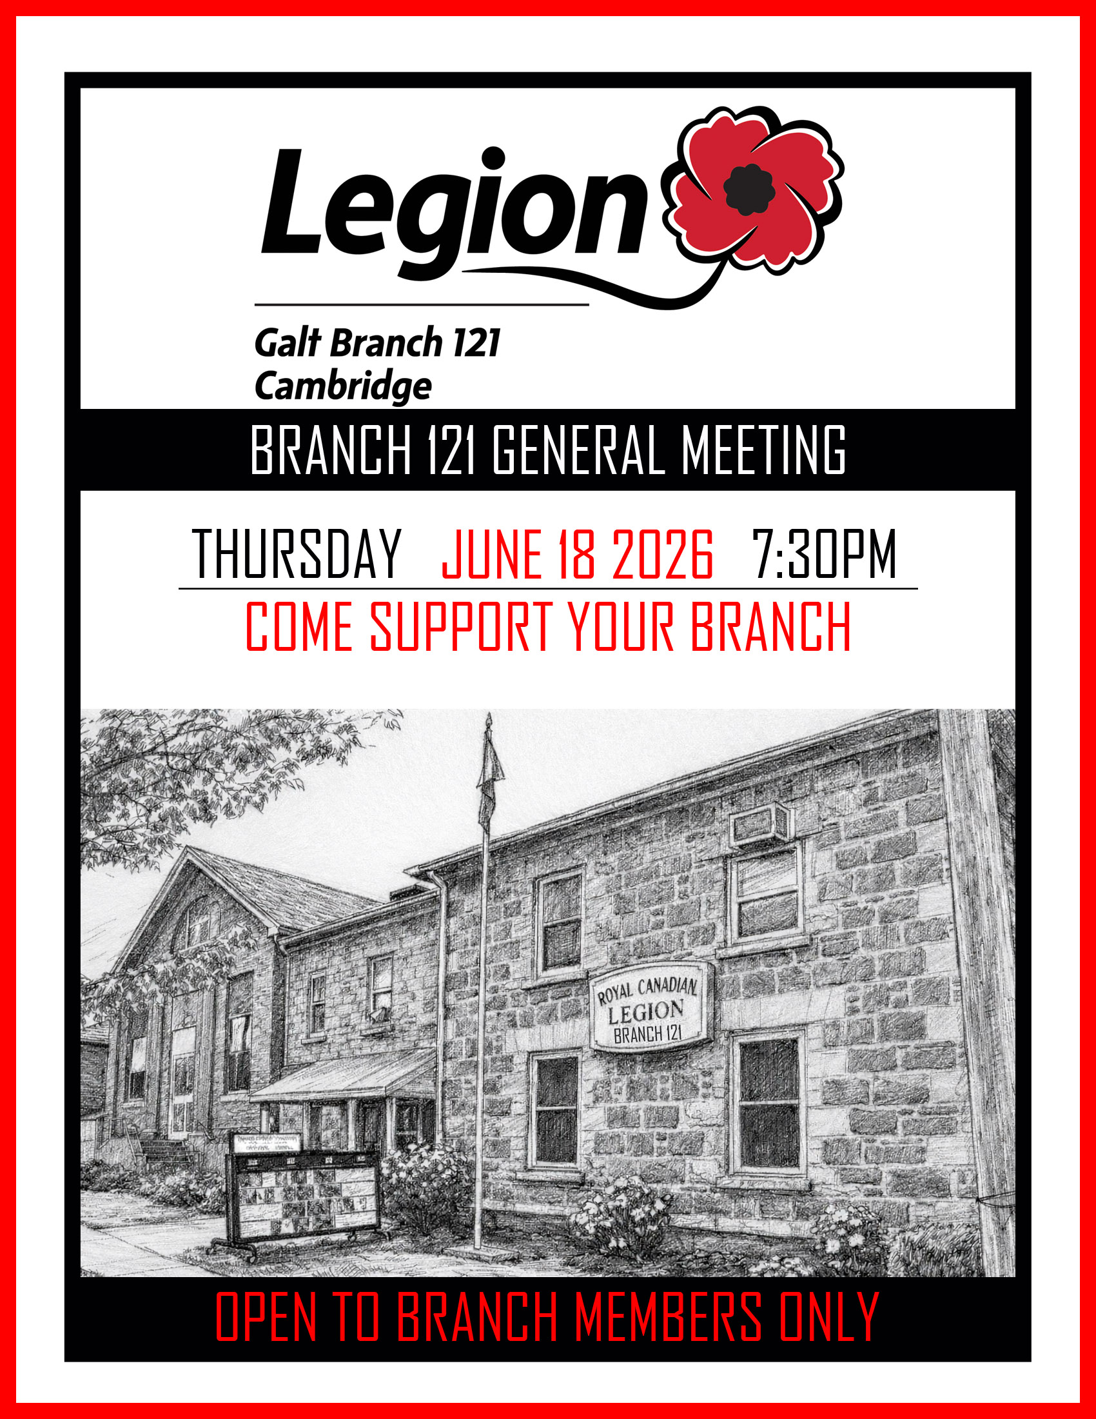


7






Members of the Galt Legion executive team rolled up their sleeves and headed over to Tim Hortons to decorate Smile Cookies in support of our local food bank. It was a fun, hands-on way to give back to the community—one cookie at a time!
Every smile we helped create goes a little further in supporting those who need it most. We’re proud to be part of a community that shows up, pitches in, and makes a difference.
They decorated almost 500 cookies.
President Mookie 1st Vice Presiden Sandra 2nd Presiden Vice Peter
Treasurer Paula Poppy chair Donna

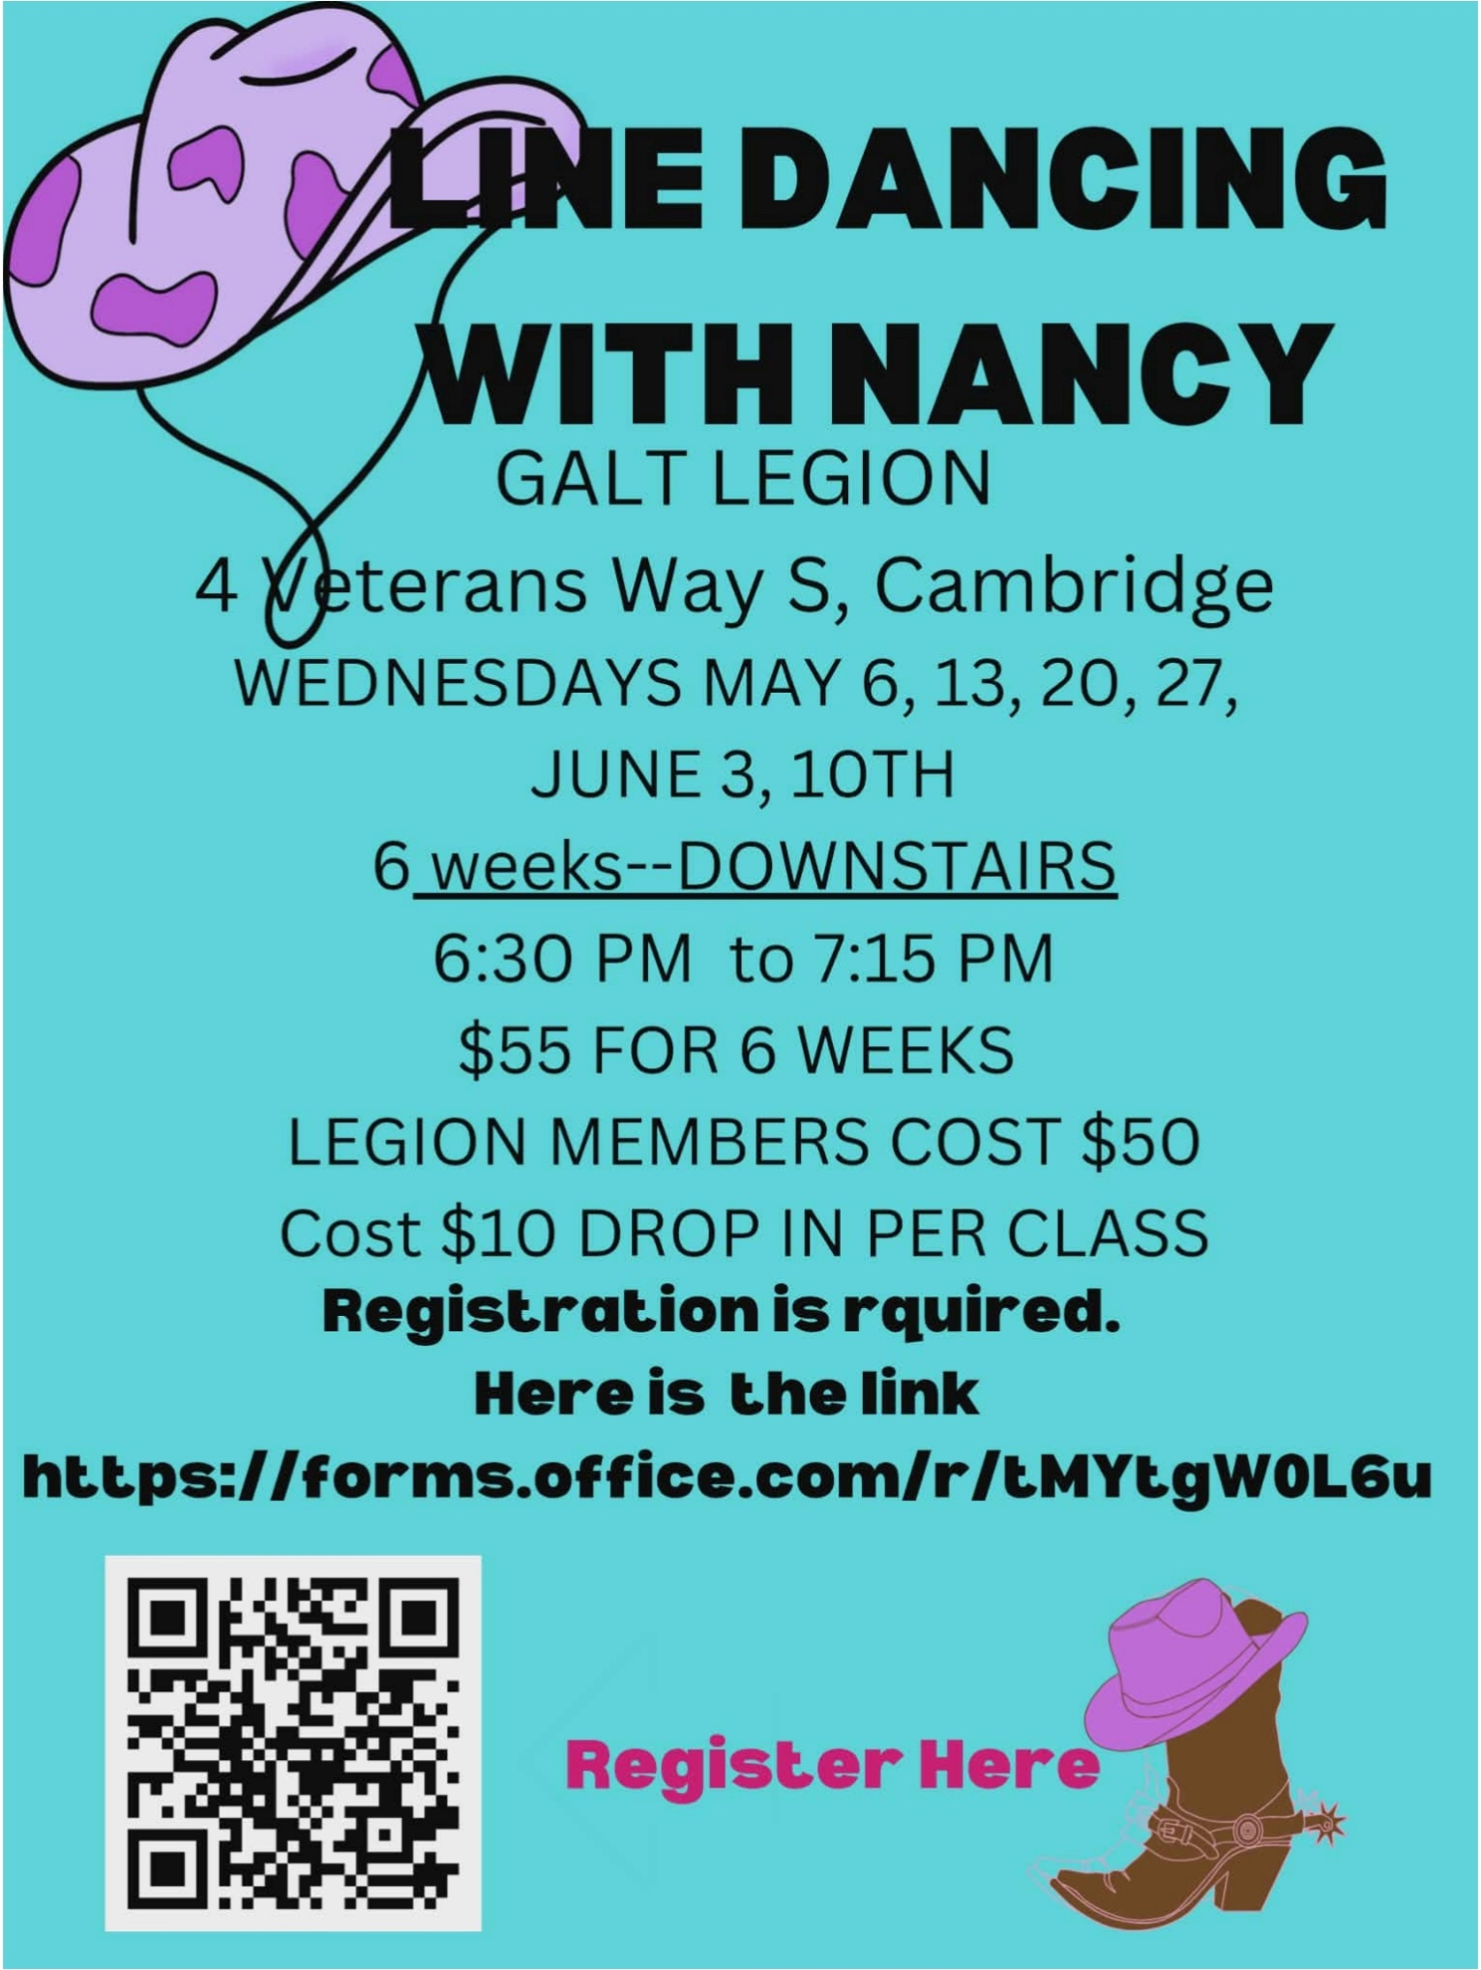








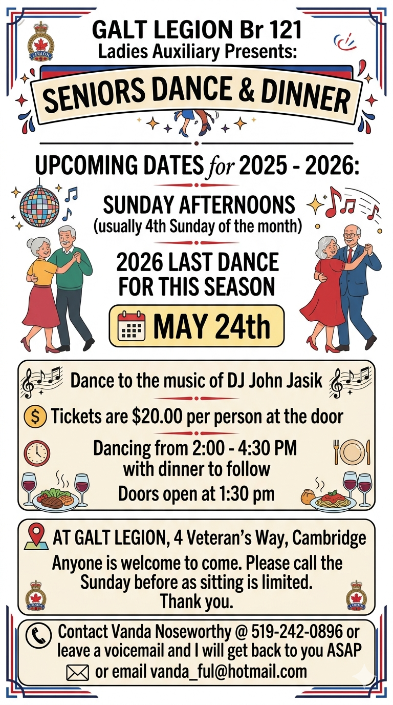











MAY - JUNE 2026

 | SUN | MON | TUES | WED | THURS | FRI | SAT
 | CLOSED | OPEN  6PM-10PM | OPEN  6PM-10PM | OPEN  6PM-10PM | CLOSED | OPEN  6PM -11PM | OPEN  12PM -6PM
 | may 17 | may 18  victoria dAY  CLOSED | may 19  Blue Grass  Jam Night  Come Listen  7PM | may 20  League Snooker  6:30PM  Line Dancing | may 21  General MTG  7:30 pm | may 22  Kareoke  With Kris G  7PM  Awards  7pm | may 23  Super Meat Draw  2PM
 | MAY 24  Seniors dinner-dance  $20  2-4:30 pm | MAY 25  Dart League  Spares Welcome  7PM | MAY 26  Blue Grass  Jam Night  Come Listen  7PM | MAY 27  League Snooker  6:30PM  Line Dancing | MAY 28  Lasagna  Dinner  4-7pm | MAY 29  Kareoke  With Kris G  7PM | MAY 30  Meat Draw  2PM  Trivia  6pm
 | MAY 31 | JUNE 1  Dart League  Spares Welcome  7PM | JUNE 2  Blue Grass  Jam Night  Come Listen  7PM | JUNE 3  League Snooker  6:30PM  Line Dancing | JUNE 4 | JUNE 5  Kareoke  With Kris G  7PM | JUNE 6  Meat Draw  2PM
 | JUNE 7 | JUNE 8  Dart League  Spares Welcome  7PM | JUNE 9  Blue Grass  Jam Night  Come Listen  7PM  EXEC. MTG.  7 pm | JUNE 10  League Snooker  6:30PM  Line Dancing | JUNE 11 | JUNE 12  Kareoke  With Kris G  7PM | JUNE 13  Meat Draw  2pm  District C  Youth  Track & Field
 | JUNE 14  LA Breakfast  8:30 - 11:00  Adults $12  6-10 $5  5 & Under Free | JUNE 15  Dart League  Spares Welcome  7PM | JUNE 16  Blue Grass  Jam Night  Come Listen  7PM | JUNE 17  League Snooker  6:30PM | JUNE 18 | JUNE 19  Dance  Scary Boos  Jingle Bells  Theme | JUNE 20  Meat Draw  2PM
 | JUNE 21 | JUNE 22  Summer Hours  Closed | JUNE 23  Blue Grass  Jam Night  Come Listen  7PM | JUNE 24  League Snooker  6:30PM | JUNE 25 | JUNE 26  Kareoke  With Kris G  7PM | JUNE 27  Super Meat Draw  2PM
 | JUNE 28 | JUNE 29  Summer Hours  Closed | JUNE 30  Blue Grass  Jam Night  Come Listen  7PM

TO STAY UPDATED
VISIT OUR WEB PAGE www.galtlegion121.ca

JOIN OUR FACEBOOK PAGE Royal Canadian Legion Galt Branch 121
THE LINK CAN BE FOUND ON OUR WEB PAGE HOME PAGE JUST UNDER THE EVENTS FLYERS SANDRA AND DON BULLITEN EDITORS 121GALTLEGION@GMAIL.COM

