The Veterans Way Bulletin
JUNE - JULY 2026
 | 4 Veterans Way Cambridge, Ont.  N1R 3K7 Phone: 519-621-5850
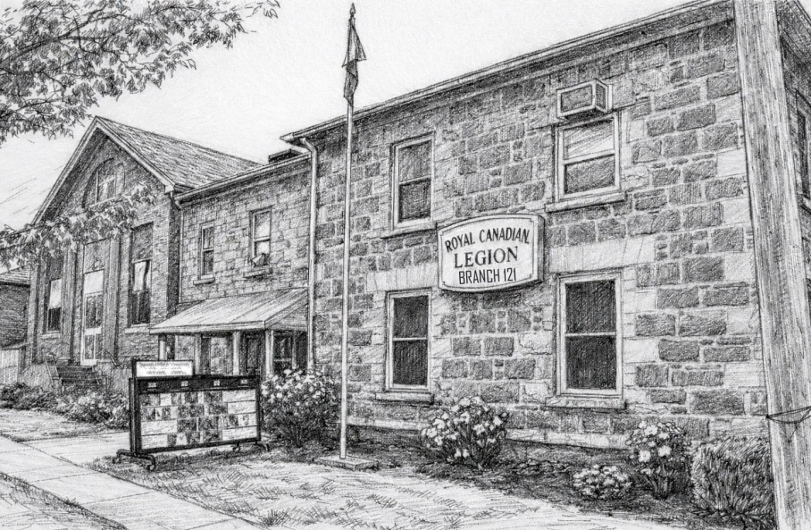

JULY-SEPTEMBER LOUNGE HOURS

MONDAY | CLOSED
TUESDAY | CLOSED
WEDNESDAY | CLOSED
THURSDAY | CLOSED
FRIDAY | 6 PM TO 11 PM
SATURDAY | 12 PM TO 6 PM -LATER FOR SOME EVENTS
SUNDAY | CLOSED

Email:121galtlegion@gmail.com Legion Web Page: http://www.galtlegion121.ca
Hall Rentals 121galtlegion@gmail.com Bulletin Submissions 121galtlegion@gmail.com

General Meeting 3rd Thursday of the month 7:30 p.m. No general meeting in July, Aug & Dec

Executive Meeting Held every 2nd Tuesday of the Month 7:00 p.m.

Executive/Committee for Branch 121 & LAdies Auxilary Listings 2025 - 2027

2 Year Term: June 1, 2025– May 31, 2027

Standing Executive
Position | First Name | Last Name | Phone #
President | Micheline (Mook) | King | 226-218-3818
Past President | Vacant
1st Vice President | Sandra | Curtis | 226-218-5483
2nd Vice President | Peter | Beswick | 519-621-1749
Secretary | Annie | Wilson | 905-518-9741
Treasurer | Paula | Baxter - Taylor | 519-654-6468
Sgt-at-Arms | Mark | McKane | 226-755-0385
Leadership & Development | Rob | Kleri | 226-898-1779
Membership | Micheline (Mook) | King | 226-218-3818
Poppy Chairman | Sandra | Curtis | 226 218-5483
PRO | Don | Taylor | 416-709-7935
Seniors | Peter | Beswick | 519-621-1749
Sports / Track and Field | Jim | Hickey | 778-839-3930
Veterans Service Officer | Peter | Beswick | 519-621-1749
Bursary/Youth Education | Ray | Boudreau | 519-740-8422

Branch Committees
Entertainment | Mook | King | 226-218-3818
Honours & Awards | Laura Lee | Fox | 519-240-8805
House and Property | Sean | Curtis | 226-218-3781
Sick and Visiting | John Hynes / Margaret McNamara |  | 519-622-2694
Financial Review | Katherine Miller
Health Safety | Mark  Rob | McKane  Kleri | 226-755-0385  226-898-1779
Bulletin Editors | Sandra and Don | 121GALTLEGION@GMAIL.COM
Bar Chairman | Sandra | Curtis | 226-218-5483
Ways and Means | Annie  Mook | Wilson  King | 905-518-9741  226-218-3818
Liaison Officer Cadets | Peter | Beswick | 519-621-1749

LADIES AUXILIARY EXECUTIVE
President / Seniors Dance & Dinner | Kerry | Evens | 226-808-3372
Past President / Catering | Betty | Laidlaw | 519-722-1271
1st Vice President | Diane | Hnatejko | 519-219-0778
2nd Vice President | Sherry | Coleman | 519-221-8241
Treasurer | Betty | Laidlaw | 519-722-1271
Secretary | Amy | Crowe | 226-753-6468
Sgt-at-Arms | Vacant
Sports officer | Amy | Crowe | 226-753-6468
Membership | Vanda | Noseworthy | 519-242-0896
Phone Chairperson | Cathy | McMurrin | 519-651-7577
Kitchen & Head Chef Coordinator | Sherry | Coleman | 519-221-8241
Volunteer Coordinator | Sherry | Coleman | 519-221-8241
Honours & Awards | Christine | Fulton | 519-242-9310
Email Ladies Auxiliary: LaAux121@gmail.com
Branch Chaplin | Rev. Frank | Squires | 519-623-3378
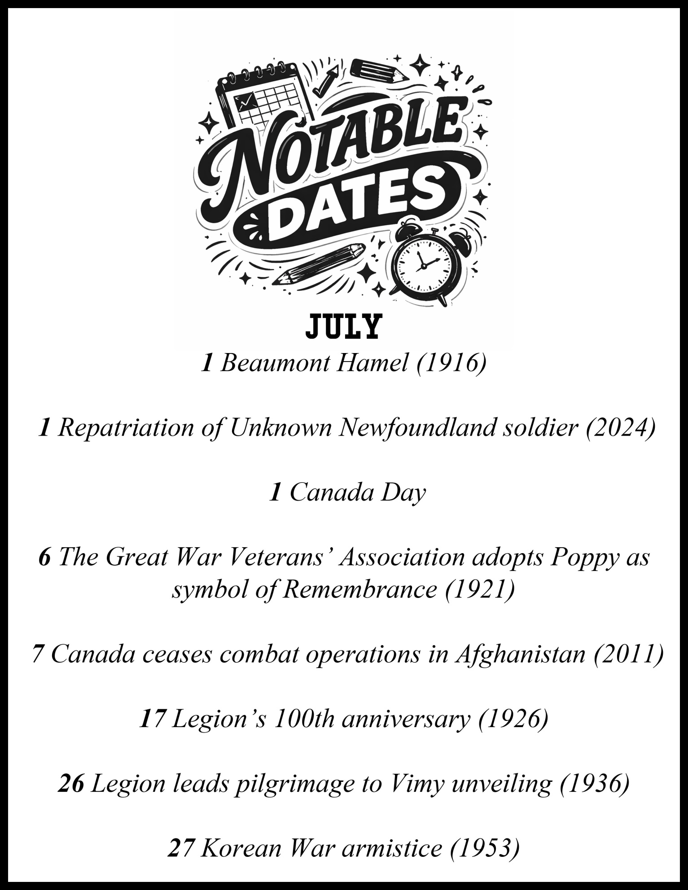



President’s MESSAGE

As we head into the summer months and begin the second year of our term, I would like to take this opportunity to thank all of our members, volunteers, veterans, and supporters for their continued dedication to our Branch and to the values of the Royal Canadian Legion.
Summer is a time to relax, spend time with family and friends, and enjoy all that our community has to offer. I encourage everyone to get out, enjoy the warm weather, and take part in the many activities happening around our Branch.
As we move forward, I look forward to welcoming new faces and seeing more members become involved in our programs and events. Whether you are a long-time member or visiting for the first time, your participation helps keep our Branch strong and vibrant.
I am also excited to announce a new Veterans Program beginning this August. On the first Saturday of every month, veterans are invited to come to the Branch and enjoy a complimentary snack and fellowship with fellow veterans. Depending on the month, the snack may range from a muffin and coffee to a hamburger or other light refreshments. This program is designed to bring veterans together, strengthen connections, and provide another opportunity for camaraderie and support.
I look forward to seeing many of you throughout the summer and especially at the launch of this new initiative in August.
On behalf of the Executive, I wish everyone a safe, healthy, and enjoyable summer.
Yours in comradeship,
President
Micheline



1st Vice President message

As I begin my second summer serving as our Branch's First Vice-President, I am reminded often of the strength, dedication, and camaraderie that makes our Branch so special.
While our hours may look a little different and we may not see one another as often during these warmer months, our commitment to supporting veterans and their families remains as strong as ever. Whether through service, remembrance, or simply being there for one another, the work of our Branch continues throughout the summer.
As we spend time with family and friends and enjoy the freedoms that many of us often take for granted, let us pause to remember those who made those freedoms possible. The sacrifices of our veterans have given us the opportunity to gather, celebrate, and enjoy the simple pleasures of life, and for that we owe them our deepest gratitude.
This year also marks a remarkable milestone: the Royal Canadian Legion is celebrating its 100th anniversary. Think about that for a moment. For a century, organizations like ours have been needed to support veterans, advocate on their behalf, and preserve their legacy. As we celebrate this historic achievement, let us also look ahead and work together to ensure that the Legion remains strong and relevant for the next 100 years.
I hope you will join us for our upcoming celebrations at the Branch on July 17th and 18th as we commemorate this incredible milestone together.
Wishing you and your families a safe, enjoyable, and memorable summer.
"We inherited a century of service. It is now our responsibility to carry it forward."
Yours in comradeship,
Sandra Curtis


Poppy and REMEMBRANCE message
As summer gets underway, it may be hard to believe, but preparations for our upcoming Poppy Campaign are already beginning.
We encourage all members to take some time to consider how they may be able to assist with this important initiative. When we joined the Legion, supporting the Poppy Campaign was part of our commitment as members, and its success depends on the active participation of our Branch volunteers.
There are many ways to help, including:
• Delivering and monitoring Poppy donation boxes throughout the community
• Collecting and counting donations from donation boxes
• Sorting and packaging poppies for distribution
• Assisting with preparations for Remembrance Day
• Helping set up chairs, audio equipment, and other requirements at the Cenotaph
• Providing general support wherever needed during the campaign
If you are willing to volunteer, please send an email to the Branch with your contact information, including your email address and phone number. We will compile a volunteer list and reach out as assistance is required.
121galtlegion@gmail.com
When responding, please indicate the days and times you are generally available so we can plan accordingly.
Thank you for helping us honour and remember those who served. Your support makes a meaningful difference in ensuring the success of our Poppy Campaign
This year especially as The Royal Canadian Legion celebrates its 100th anniversary!
“Their sacrifice. Our remembrance.”
Yours in comradeship,
Sandra Curtis

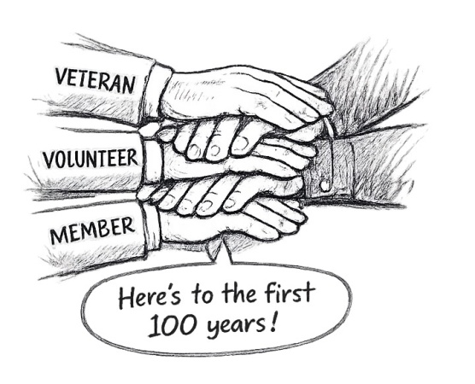

Ladies Auxilary President’s MESSAGE

HELLO
Over the past 6 months The ladies auxiliary has been busy restructuring their office, the kitchen and our executive.

The LA has a new email address galtlabr121@gmail.com
Please use this email for any correspondence you want the ladies auxiliary to know, whether good or bad.

For your catering needs please call Catering & Celebration of Life Coordinator
Christine Fulton 519-242-9310

We had a LA Provincial Convention held in Bracebridge on May 31 to June 2… Attending this event was Amy Crowe, Vanda Noseworthy, Betty Laidlaw and Marg Rose.

We are still doing breakfasts and senior dances…. Look in the newsletter for these events dates.

Our executive meetings is the first Wednesdays of the month, and our general meetings is the second Wednesdays of the month.

Here is the list of our new executive and their positions for the 2-year term June 1, 2025 to May 31, 2027:
EXECUTIVE OFFICERS:
President Kerry Evens 226-808-3372
1st Vice President Diane Hnatejko 519-219-0778
2nd Vice President VACANT
Immediate Past President Betty Laidlaw 519-722-1271
Secretary Amy Crowe 226-753-6468
Treasurer Betty Laidlaw 519-722-1271
Sgt-at-arms VACANT
Sports Officer Amy Crowe 226-753-6468

LA COMMITTEE:
Catering & Celebration of Life Coordinator
Christine Fulton 519-242-9310
LA LIASON with the Branch Vanda Noseworthy 519-242-0896
Kitchen & Head Cook Coordinator VACANT
Volunteer Coordinator VACANT
Membership Vanda Noseworthy 519-242-0896
Honours & Awards Christine Fulton 519-242-9310
LA Breakfast Vanda Noseworthy 519-242-0896
Seniors Dance/Dinner Vanda Noseworthy 519-242-0896
Phone Chairperson Cathy McMurran 519-651-7577
I hope everyone have a safe and fun summer.
THANK YOU
Kerry Evens
LA Br 121 President








7
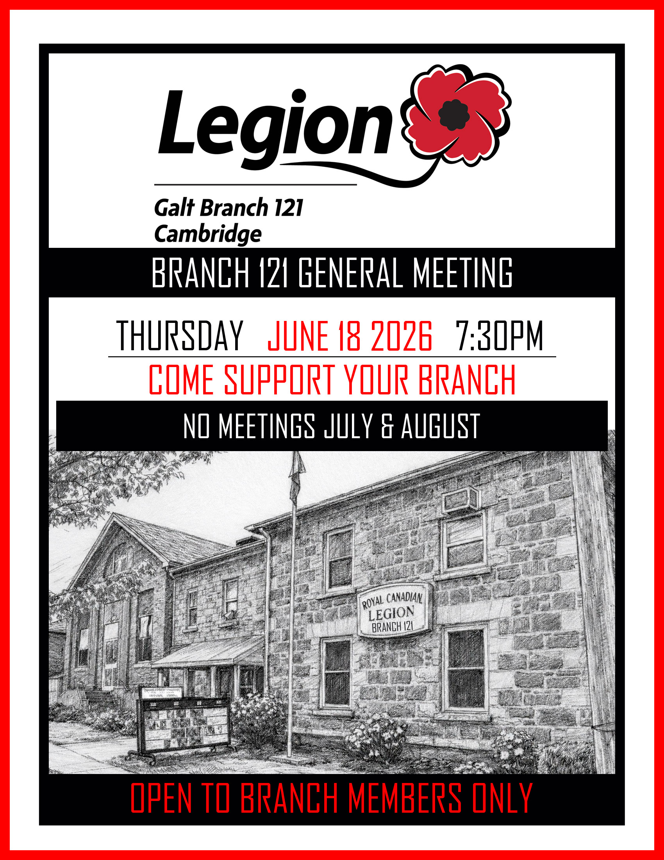
























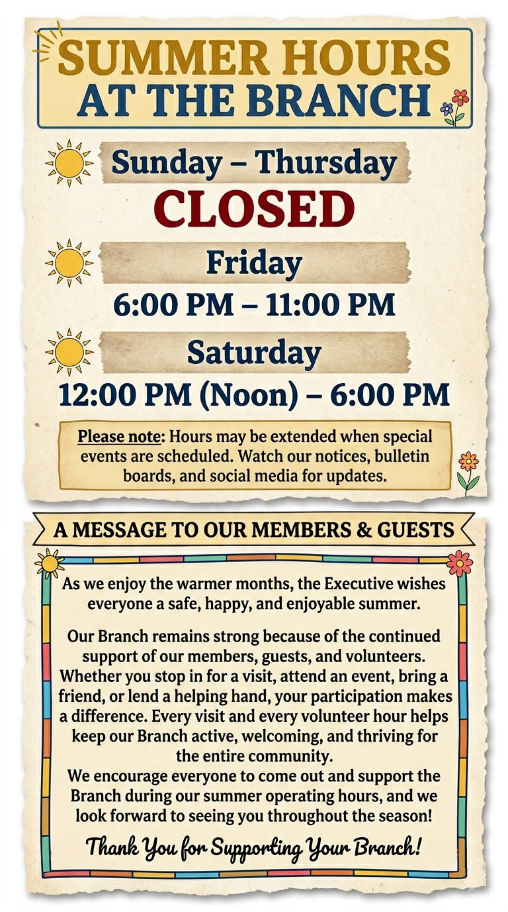

JUNE -JULY 2026

 | SUN | MON | TUES | WED | THURS | FRI | SAT
 | CLOSED | CLOSED | CLOSED | CLOSED | CLOSED | OPEN  6PM -11PM | OPEN  12PM -6PM
 | JUNE 14 | JUNE 15 | JUNE 16 | JUNE 17 | JUNE 18  General MTG  7:30 pm | JUNE 19  Dance  Scary Boos  Jingle Bells  Theme | JUNE 20  BINGO 1PM  Meat Draw 2PM
 | JUNE 21 | JUNE 22 | JUNE 23 | JUNE 24 | JUNE 25  canada day BBQ  DINNER | JUNE 26  Kareoke  With Kris G  7PM | JUNE 27  Canada day fun  Super Meat Draw 2PM  Music 3-5pm  Trivia 6pm
 | JUNE 28 | JUNE 29 | JUNE 30 | JULY 1  Canada day  parade  preston king st | JULY 2 | JULY 3  Kareoke  With Kris G  7PM | JULY 4  BINGO 1PM  Meat Draw 2PM
 | JULY 5 | JULY 6 | JULY 7 | JULY 8 | JULY 9 | JULY 10  Kareoke  With Kris G  7PM | JULY 11  BINGO 1PM  Meat Draw 2PM
 | JULY 12 | JULY 13 | JULY 14  EXEC. MTG.  7 pm | JULY 15 | JULY 16 | JULY 17  LEGION 100TH  SEE BULLITEN & POSTS  Kareoke  With Kris G  7PM | JULY 18  LEGION 100TH  SEE BULLITEN & POSTS  Super Meat Draw 2PM
 | JULY 19 | JULY 20 | JULY 21 | JULY 22 | JULY 23 | JULY 24  Kareoke  With Kris G  7PM | JULY 26  Meat Draw  2PM
 | JULY 27 | JULY 28 | JULY 29 | JULY 30 | JULY 31

TO STAY UPDATED
VISIT OUR WEB PAGE www.galtlegion121.ca

JOIN OUR FACEBOOK PAGE Royal Canadian Legion Galt Branch 121
THE LINK CAN BE FOUND ON OUR WEB PAGE HOME PAGE JUST UNDER THE EVENTS FLYERS SANDRA AND DON BULLETIN EDITORS 121GALTLEGION@GMAIL.COM

